Small Comet and Mine Rack

Modular Peg Board System

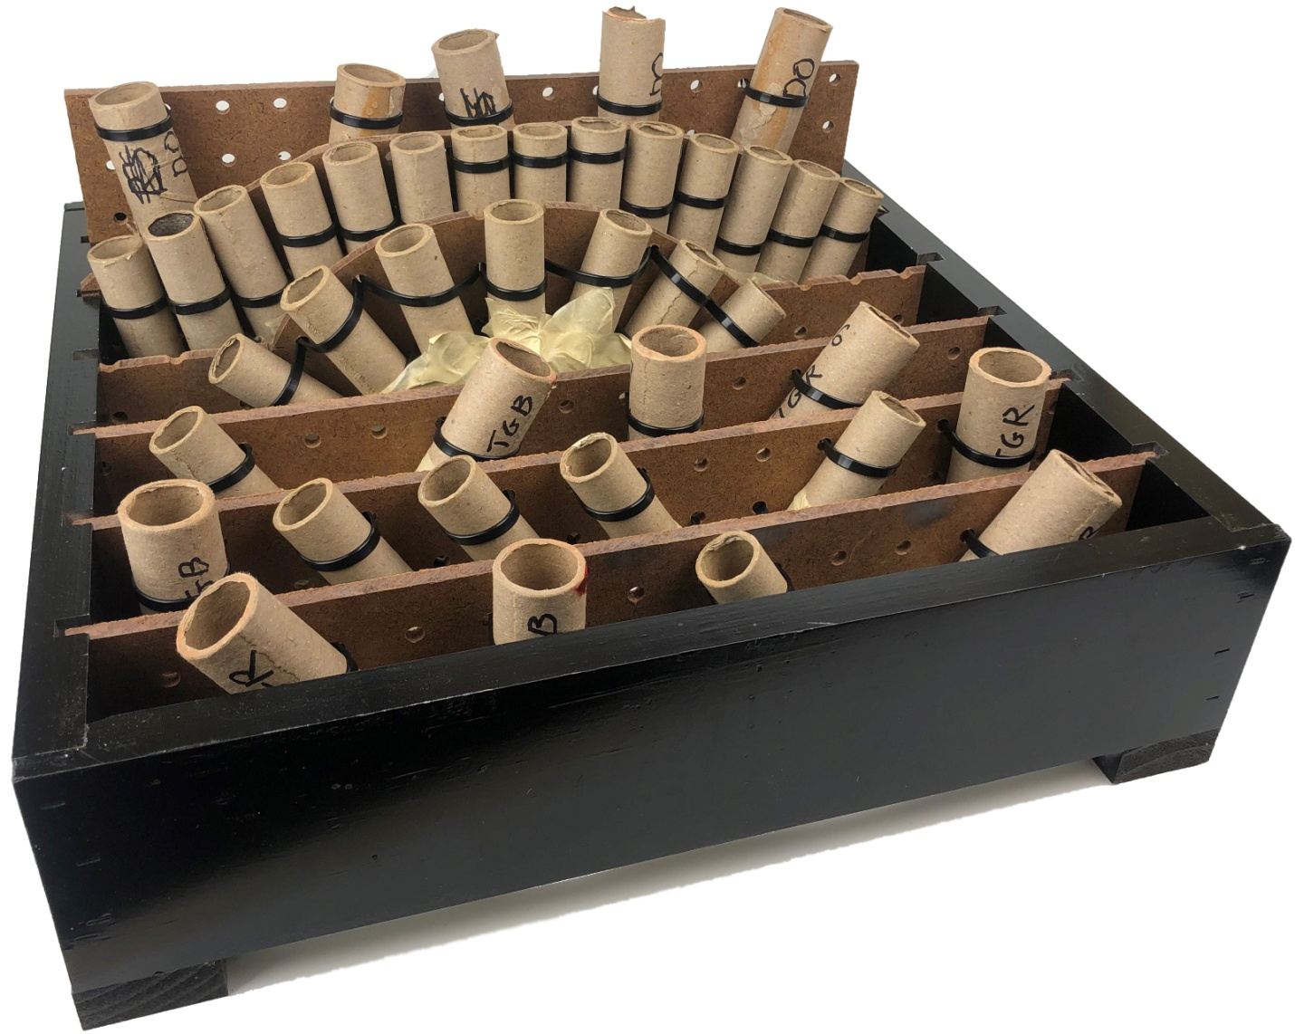

By Michael Smith

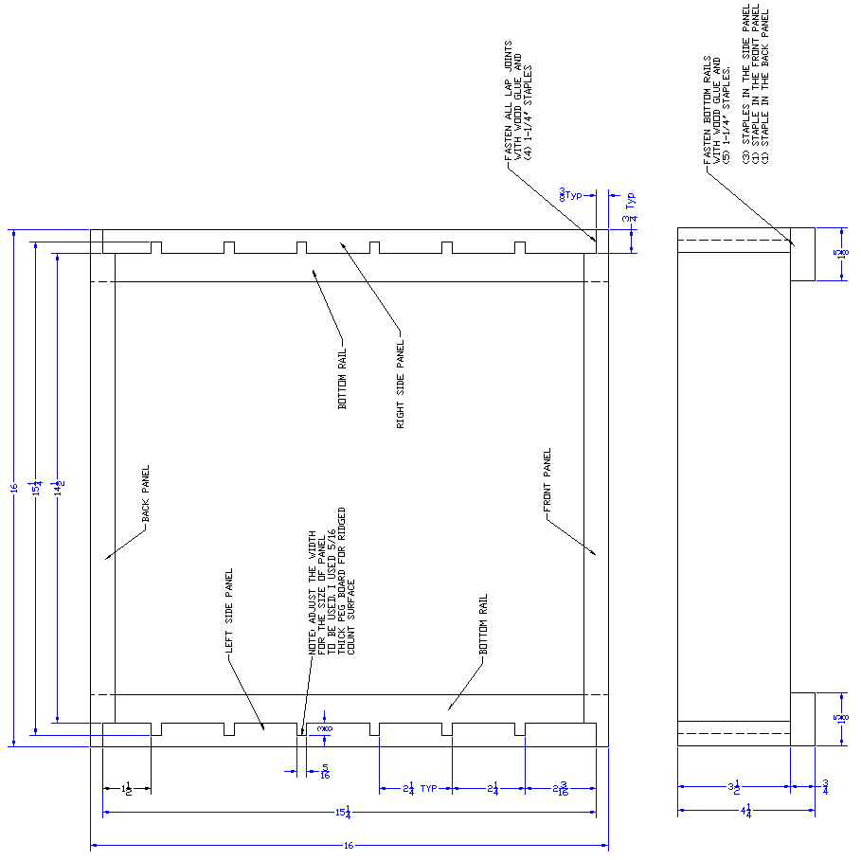

FINISH: FILL ALL STAPLE HOLES WITH WOOD FILLER OR PUTTY. SAND, PRIME, AND PAINT.

I PREFER PAINTING WITH KRYLON APPLIANCE EPOXY SPRAY PAINT FOR DURABILITY AND

PERCEIVED RESILIANCE AGAINT AMBERS AND FALLOUT

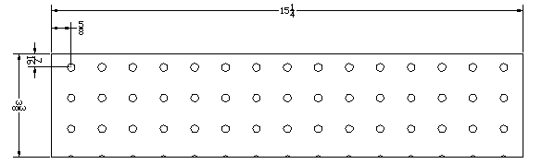

3-3/8" x 15-1/4" PANEL

NOTE ACTUAL SIZE IS 1/8" SHORT ON HEIGHT AS COMPARED TO THE RACK SIDE TO KEEP THE HOLE PATTERN THE SAME ASSUMING 1/8" SAW BLADE. THIS IS TO KEEP A HOLE CLOSE TO THE TOP FOR SECURING THE FIREWORK CLOSE TO THE TOP EDGE. WITH THIS SPACING, THE PANELS WILL REMAIN CONSISTANT WHEN CUTTING ON TABLE SAW.

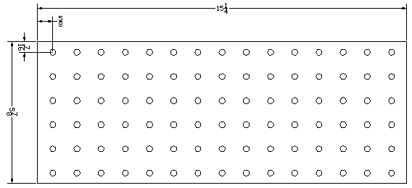

5-7/8" x 15-1/4" PANEL

KEEP A HOLE CLOSE TO THE TOP FOR SECURING THE FIREWORK CLOSE TO THE TOP EDGE. WITH THIS SPACING, THE HOLE PATTERN WILL REMAIN CONSISTANT WHEN CUTTING ON TABLE SAW.

**NOTE**: Modify the panels as needed for your firework configuration. The goal is to have good support for the fireworks and to have the top of the firework extend past the mounting panel to avoid scorching and excessive heat on the panel.

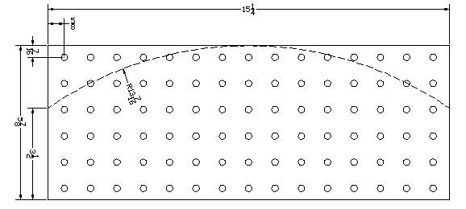

SAMPLE MODIFIED PANEL - LARGE CURVE

THIS DESIGN IS GOOD FOR MAKING A FAN EFFECT USING A LARGER QUANTITY OF TUBES

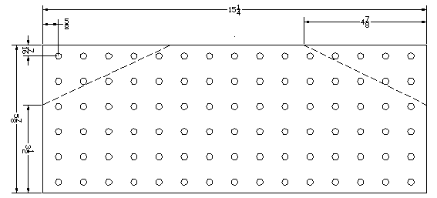

SAMPLE MODIFIED PANEL - ANGLED

THIS DESIGN IS GOOD FOR LARGE FANS OR WHEN SEQUENCING LEFT, CENTER, AND RIGHT ANGLED SHOTS

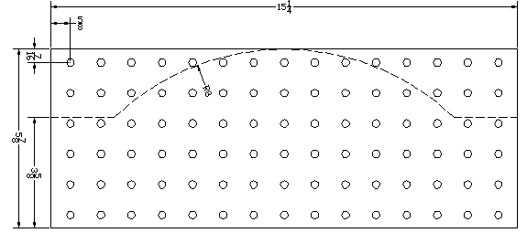

SAMPLE MODIFIED PANEL – SMALL CURVE

THIS DESIGN IS GOOD FOR SMALL FANS. YOU CAN STILL LOAD A TUBE ON THE LEFT OR RIGHT WHEN SHOOTING STRAIGHT UP BEFORE OR AFTER THE FAN

